SIMATS ENGINEERING (SAVEETHA SCHOOL OF ENGINEERING)
Department of Computer Science and Engineering
CO1 ASSESSMENT TOOL 1 – Case Study Analysis
Course Code: | CSA10 / CSA1063 | Course Title: | Software Engineering
CO Assessed: | CO1 | Assessment: | Assessment Tool 1 – Case Study Analysis
Weightage: | 20% | Total Marks: | 25
CO1 Statement: | Apply advanced methodologies and agile project management techniques to manage software projects effectively
Student Name: | K V CHARAN TEJA | Reg. No.: | 192424167
Date: | 22-07-2026 | Duration: | 60 minutes

Code of Conduct
I __A.Akshaya(192425170)________ (Name / Reg No) certify that this submission is my original work and that I have adhered to the guidelines specified for this assessment. I understand that any violation of academic integrity rules will result in disciplinary action.
Signature of the Student: ____________Akshaya_____________

Annexure A – Case Study Analysis
Instructions to Students:
Domain: Banking & Finance
Problem Statement: Blockchain-Based Secure Banking Transaction Management System
Based on your allotted problem statement, prepare a report by answering the following questions:
Blockchain Banking System:
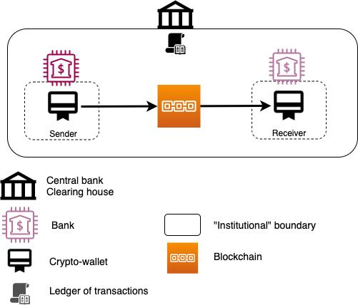
1. Understand the Problem Statement
Explain the problem in your own words
The traditional banking transaction system depends on centralized databases to store and process financial records. Although these systems are widely used, they are vulnerable to cyberattacks, unauthorized access, data manipulation, fraud, and single points of failure. As the number of online banking users continues to increase, banks require a more secure, transparent, and reliable transaction management system. Blockchain technology provides a decentralized ledger where every transaction is verified, encrypted, and permanently recorded. Since the data cannot be modified without network consensus, blockchain significantly reduces fraud and improves trust between customers and financial institutions. The proposed Blockchain-Based Secure Banking Transaction Management System ensures secure fund transfers, transparent transaction history, faster verification, and enhanced data integrity while minimizing operational risks.

Objectives of the Proposed System
- Develop a secure blockchain-based banking transaction platform.
- Prevent unauthorized modification of banking records.
- Improve transparency in financial transactions.
- Enable secure peer-to-peer fund transfers.
- Reduce fraud through immutable transaction records.
- Provide real-time transaction verification.
- Ensure customer privacy using cryptographic encryption.
- Improve banking efficiency with smart contract automation.

Scope
The proposed system can be used by commercial banks, private banks, cooperative banks, digital banking platforms, and financial institutions. It supports customer registration, secure fund transfers, blockchain ledger management, transaction validation, fraud prevention, user authentication, and administrative monitoring. The system enhances banking security while reducing transaction costs and increasing customer trust.
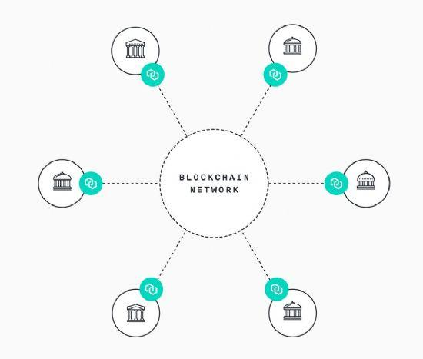

2. Identify Key Stakeholders
Stakeholders
- Customers
- Bank Employees
- Bank Manager
- System Administrator
- Financial Institutions
- Blockchain Network Validators
- Government Regulatory Authorities
- Cybersecurity Team

Stakeholder Roles
Customers
- Register accounts
- Transfer money
- View transaction history
- Verify transactions
Bank Employees
- Verify customer details
- Approve banking requests
- Assist customers

Bank Manager
- Monitor banking operations
- Generate reports
- Manage employees
System Administrator
- Maintain blockchain nodes
- Manage servers
- User management
- Security monitoring
Regulatory Authorities
- Ensure compliance
- Monitor legal standards

Major Challenges
- Increasing cyber attacks
- Online banking fraud
- Identity theft
- Data privacy
- Secure transaction verification
- High transaction volume
- Regulatory compliance
- Blockchain scalability


3. Analyze Current Approach
Existing System
Most banks use centralized databases where all customer information and transaction records are stored in one location. While centralized systems are efficient, they are vulnerable to hacking, insider attacks, server failures, and data tampering. If the central server is compromised, sensitive banking information may be exposed.

Strengths
- Fast transaction processing
- Easy account management
- Centralized monitoring
- Well-established banking infrastructure
- Customer support services

Limitations
- Single point of failure
- Higher risk of cyber attacks
- Data tampering possibility
- Limited transparency
- High maintenance cost
- Manual fraud detection

Problems to Address
- Improve transaction security
- Prevent unauthorized modifications
- Reduce fraud
- Increase transparency
- Ensure data integrity
- Improve customer trust

4. Proposed Software Solution
The proposed Blockchain-Based Secure Banking Transaction Management System uses blockchain technology to record every banking transaction securely. Every transaction is encrypted using cryptographic hashing and verified by blockchain nodes before being added to the ledger. Once stored, the information cannot be modified or deleted, ensuring complete transparency and integrity. Customers can securely transfer funds, verify transactions, and access their transaction history while administrators monitor system performance and regulatory compliance.

Functional Modules
Customer Module
- Registration
- Login
- Fund Transfer
- Balance Inquiry
- Transaction History
Authentication Module
- OTP Verification
- Multi-Factor Authentication
- Identity Verification
Blockchain Module
- Block Creation
- Transaction Validation
- Hash Generation
- Distributed Ledger
Smart Contract Module
- Automatic Verification
- Transaction Approval
- Settlement
Admin Module
- User Management
- Security Monitoring
- Audit Reports
Fraud Detection Module
- Suspicious Activity Detection
- Risk Alerts
- Transaction Monitoring

Functional Requirements
- Customer Registration
- Secure Login
- Fund Transfer
- Transaction Verification
- Blockchain Ledger
- Smart Contracts
- Report Generation
- Fraud Detection
- Admin Dashboard

Non-Functional Requirements
- Security
- Reliability
- Scalability
- Availability
- Performance
- Maintainability
- Usability
- Privacy

Software Engineering Principles
Modularity
Separate modules for Customers, Blockchain, Authentication, Transactions, Smart Contracts, Fraud Detection, and Administration.
Scalability
Supports millions of banking transactions.
Maintainability
Independent modules simplify updates.
Reliability
Blockchain ensures accurate transaction records.
Usability
Simple and user-friendly banking interface.
Security
Encryption, digital signatures, hashing, blockchain validation, and multi-factor authentication provide high security.

5. Methodology
Selected SDLC
Agile Software Development Model

Justification
Agile supports iterative development, continuous testing, rapid bug fixing, stakeholder feedback, and easy integration of new banking features. Since banking applications require frequent security updates and regulatory compliance, Agile is the most suitable methodology.

How Agile Supports Development
- Continuous testing
- Better security updates
- Customer feedback
- Faster deployment
- Easy maintenance
- Incremental improvements
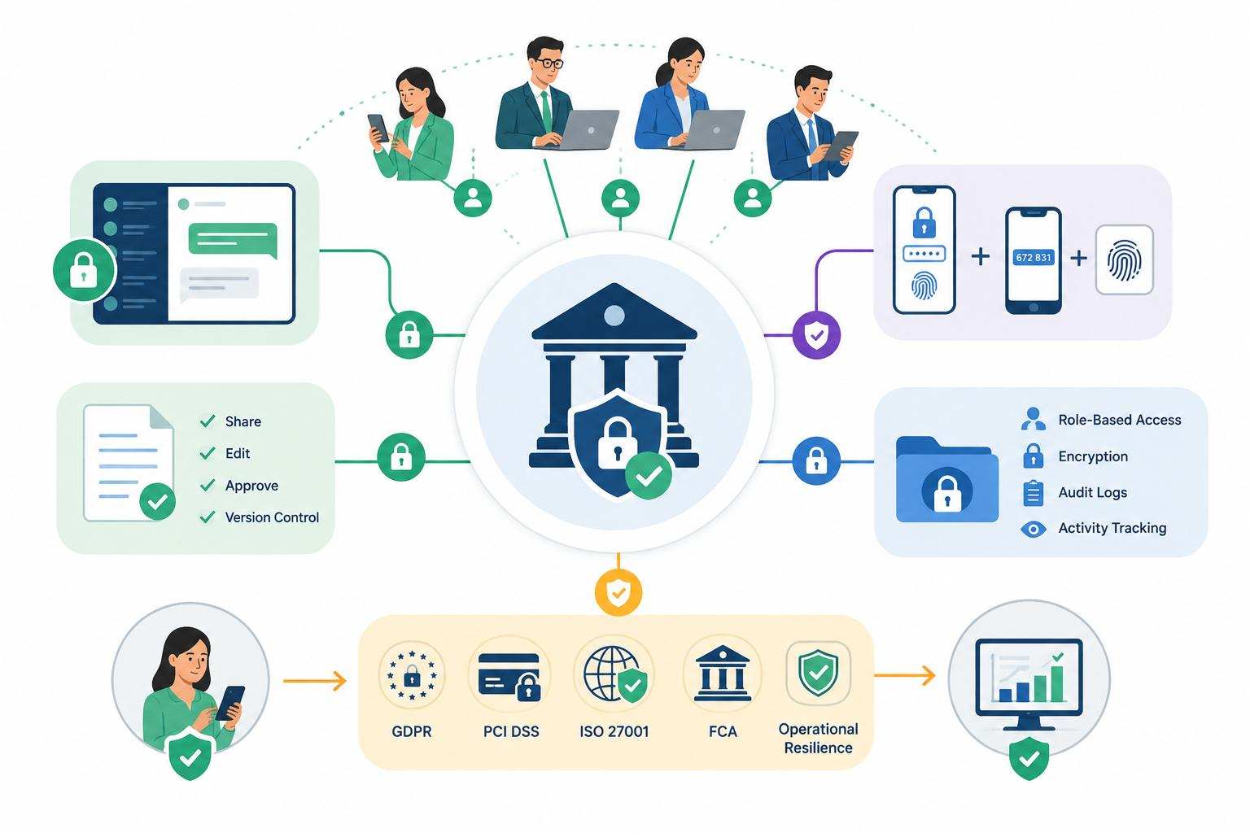

6. Expected Outcomes
Benefits
- Secure online banking
- Tamper-proof transaction records
- Faster verification
- Reduced fraud
- Higher transparency
- Improved customer trust
- Better regulatory compliance
- Lower operational cost

Solution Addresses Challenges
The blockchain system prevents unauthorized access through decentralized verification and encryption. Every banking transaction is permanently stored in an immutable ledger, making fraud and record tampering extremely difficult. Smart contracts automate transaction validation, while multi-factor authentication enhances account security. These features improve transparency, reliability, and trust in digital banking services.

Risks & Limitations
- Initial implementation cost
- Blockchain scalability issues
- Regulatory challenges
- High storage requirements
- Integration with legacy banking systems
- User awareness and training

Future Enhancements
- AI-based Fraud Detection
- Quantum-resistant Cryptography
- Biometric Authentication
- Cross-border Blockchain Payments
- CBDC Integration
- IoT-enabled Banking
- Real-time Risk Analytics
- Decentralized Digital Identity
- AI Chatbot Support
- Blockchain-based Loan Management
Rubrics for Calculation
Criteria | Excellent (5 Marks) | Good (3 Marks) | Satisfactory (2 Marks) | Needs Improvement (1 Mark)
Problem Understanding | Clearly explains the problem, objectives, and scope with complete understanding. | Explains the problem with minor omissions. | Basic understanding with limited explanation. | Poor understanding; objectives and scope are unclear or missing.
Stakeholder & Challenge Analysis | Identifies all stakeholders, their roles, and challenges with clear analysis. | Identifies most stakeholders and challenges with adequate analysis. | Identifies only a few stakeholders or challenges. | Stakeholders and system analysis are incomplete or inaccurate.
Current System Analysis | Thoroughly analyzes the existing system, strengths, weaknesses, and identifies all gaps. | Good analysis with most strengths and weaknesses identified. | Limited analysis with partial identification of issues. | Proposed solution is unclear or inappropriate; requirements are largely missing.
Proposed Software Solution & Software Engineering Principles | Proposes an innovative, feasible solution applying appropriate software engineering principles (modularity, scalability, maintainability, security, etc.). | Suitable solution with good application of software engineering principles. | Basic solution with limited application of software engineering principles. | Methodology is inappropriate, poorly justified, or not discussed.
Methodology/ Framework Justification | Selects the most suitable SDLC/model/framework and provides strong technical justification. | Suitable methodology selected with adequate justification. | Methodology selected but justification is weak. | Outcomes, limitations, or future enhancements are missing; report lacks organization and clarity.

Criteria | Mark
Problem Understanding | /5
Stakeholder & Challenge Analysis | /5
Current System Analysis | /5
Proposed Software Solution & Software Engineering Principles | /5
Methodology/ Framework Justification | /5
TOTAL | /5

